# ITRW313

Prakties 1

Practical 1 12/02/2019

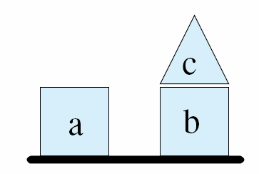

Die volgende konfigurasie van elemente word gebruik in ‘n tipiese Kunsmatige Intelligensie voorbeeld. Die blokkies word beskryf met behulp van die volgende sinne:

*The following configuration of elements is used in a typical Artificial Intelligence example. The blocks are described using the following sentences:*

C is a pyramid.

A is a cube.

B is a cube.

C is on B.

A is on the table.

B is on the table.

A is clear.

C is clear.

1. Definieer drie ***deftemplates*** wat die vorm, plek en ‘oopheid’ van elke vorm beskryf. Die vorm sal bv. so lyk:
2. *Define three* ***deftemplates*** *that describe the shape, location, and ‘clearness’ of each form. The form for example will loop like this:*

(deftemplate is-a (slot letter) (slot type))

1. Herlei die sinne na feite in ‘n ***deffacts*** stelling, bv.
2. *Convert these sentences to facts in a* ***deffacts*** *statement, ex.*

(deffacts relationships

(is-a (letter c) (type pyramid))…..)

|  |  |
| --- | --- |
| (Die deffacts stellling gaan 8 verwantskappe aandui)   1. Stoor jou antwoord in ‘n .clp-lêer en toets dit in CLIPS:  * Laai die antwoordlêer in CLIPS; * Tik in (reset) * Tik in (facts) | *(The deffacts statement will contain 8 relationships)*   1. *Save your answer in a .clp-file and test it in CLIPS.*  * *Load the answer file in CLIPS;* * *Type in (reset)* * *Type in (facts)* |